Accenture Federal Services: Hiring System

IS436: Structured System Analysis and Design Professor Carlton Crabtree

Ameed Shaikh

12 December 2023

# Table of Context

Table of Context 2

Executive Summary 4

1. Business Problem 4
2. Proposed Solution: 4
3. Value 4
   1. Systems Request 5
      1. Site Contact 5
      2. Problem Summary 5
      3. Assumptions: 5
      4. Project Constraints 5
      5. Project Impact 6
      6. Preliminary Project Recommendation 6
      7. Business Requirements Description 6
      8. Team Members and Contact 6
   2. Requirements Definitions & Use Cases 7
      1. Project Requirements: 7
      2. Functional Requirements 7
      3. Nonfunctional Requirements 8
      4. Interview 8
      5. Interview Log 8
      6. Key Findings: 12
      7. Document/Artifact Analysis: 12
      8. Use Case Analysis 14
      9. Use Case 1 14
      10. Use Case 2 15
      11. Use Case 3 16
   3. Logical Process Model 18
      1. Context diagram 18
      2. Level 0 Diagram 19
      3. Level 1 Child Diagrams 20
      4. Level 1 Process 1 - Create Job Posting 20
      5. Level 1 Process 2 - Publish Job Posting 20
      6. Level 1 Process 3 - Receive Applicant Submission 21
      7. Level 1 Process 4 - Generate Applicant Report 21
      8. Level 1 Process 5 - Retrieve Applicant Report 22
      9. Level 1 Process 6 - Allocate Applicant Submission 22
      10. Level 1 Process 7 - Distribute Candidate Profile 23
      11. Data Dictionary 24
      12. Hiring Manager 24
      13. Human Resources Department 24
      14. Potential Applicant 25
      15. New Job Posting 25
      16. Job Posting 25
      17. Notification of New Posting 25
      18. Applicant Submission 26
      19. Application 26
      20. Applicant Reports 26
      21. Notable Candidate Qualities 26
   4. Logical Data Model 27
      1. : Entity-Relationship Diagram 27
      2. Alternative Matrix 1 - Choosing the Appropriate System Design 29
      3. : Alternative Matrix 2 - Choosing the Appropriate Architecture Based on Non-functional Requirements 32
      4. : Hardware and Software Specifications 34
   5. User Interface, Physical Process & Data Models 34
      1. Structure Chart 34
      2. User Interface 35
      3. Interface Design Prototype 36
      4. Physical Process Modeling 43
      5. Physical Data Modeling 45

Appendix: Administrator Notes 47

1. Systems Request Notes 47
2. Requirements Definitions & Use Cases Notes 47
3. Logical Process Modeling Notes 47
4. Logical Data Modeling Notes 47
5. User Interface, Physical Process Modeling, and Physical Data Modeling Notes 47

# Executive Summary

1. ​Business Problem:

Accenture Federal Services is struggling from a lack of talent acquisition. The company is unable to attract candidates and efficiently position them with a hiring manager. The process is slow, cumbersome, and outdated, and oftentimes Team Leaders must find people on their own to expedite the hiring process. The application portal is outdated and inefficient, with an unintuitive hiring website that puts more work on the applicant to find a potential open position. There is no sort of feature to filter open positions by job type, and positions are not regularly posted to the website, with many filled positions still being on the website. Additionally, talent acquisition workers aren’t sorting and reading through resumes at an acceptable rate. Finally, Team Managers aren’t being given new talent to add to their teams often- and the resume delivery system is done over traditional email.

Throughout my participation in the IS 436 Structured Systems Analysis and Design course at UMBC I was able to learn more about the concerns of management through interviews and indirect observation of company artifacts. This enabled me to more fully understand the challenges faced by the Team Managers in the operating environment. The result of my efforts is presented in this final capstone project report which aims to streamline the hiring process to effectively sort through candidates to put them in front of hiring managers.

1. ​Proposed Solution:

My proposed solution is to streamline the talent acquisition pipeline to drastically reduce turnaround time and provide a more organized system. This is done through a documented interpretation of a future information system that has the potential to revitalize and resolve the current problem faced by Accenture Federal Services. By generating a more comprehensive applicant profile from the beginning of the process, hiring managers are better able to see what candidates are applying to the company. By collecting additional data on the individual candidates at the start of an application, more well-rounded and detailed profiles can be built for each candidate to properly place them into the appropriate pool to be seen by the relevant team leader. I also propose a better delivery system to team leaders for applicant information, as the current system is a standard email- which is often missed or overlooked by team leaders.

Collecting and sorting applicant data into a more comprehensive report enables Team Managers to sort applications based on relevant skills and resumes, allowing for more talented candidates to be matched to open positions faster.

1. ​Value:

The value of this solution is hopefully a more comprehensive applicant management system- one that will bring in more potential candidates and keep them in the system without losing them to other companies. It will also alleviate the stress on hiring managers and team leaders to find and place candidates into vacant positions while making a satisfactory and smooth transition for the applicant. By creating a more comprehensive and efficient system, the company will be able to bring in talent that will aid the company in their business goals without having large latency on filling vacancies.

Section 1 of this report includes the Systems Request which summarizes the business need and motivation to initiate this project. Section 2 includes a formalized list of specific requirements

for the information system. Section 3 of this report outlines the functional and nonfunctional requirements, along with three distinct use cases for this system, and results from the interview with my site contact. Section 4 of this report includes a full entity-relationship diagram (ERD) that breaks down the relationships between the different entities in this system. Finally, section 5 of this report is a prototype of the proposed solution, along with a physical process model and a structure chart for my proposed system solution.

# Systems Request

* + 1. ​Site Contact:

Whitney Anderson-Shortt, Accenture Federal Services, [whitneytanderson@gmail.com](mailto:whitneytanderson@gmail.com)

* + 1. ​Problem Summary:

Accenture Federal Services employs over 624,000 employees across the country and provides services across a multitude of industries. With a steep hiring demand, and a goal to hire 200,000 people every year, the company has a poor method of acquiring and keeping talent. The current job portal is incredibly outdated and user unfriendly- with a lot of time being wasted on narrowing down the desired department or role based on a poor filtering system and unintuitive hiring website. Recruiting people into certain departments is also a problem as well- hiring managers aren’t being presented with enough talent to fill the required positions, and oftentimes these managers are forced to directly recruit themselves and push these candidates through the hiring process. This places a large burden on project managers to find qualified candidates to fill the roles required for their contracts, causing a burden on managers who are now required to balance these tasks with their day-to-day managerial tasks. Additionally, there is very little in person recruiting being done, with Accenture having zero presence in regional or local area career fairs and other hiring events.

* + 1. ​Assumptions:
       1. The following assumptions apply to the Accenture Project. As project planning begins and more assumptions are identified, they will be added accordingly.
       2. Funding is available to revitalize the hiring portal.
       3. All talent acquisition staff will be trained on how to use and understand the new software.
       4. Funding is available to send recruiting staff to local hiring events.
       5. Project has executive level support and backing.
       6. Hiring managers will be made aware of and trained on how to correctly place talent.
       7. Funding is available to revitalize the new hire program.
       8. Funding is available to hire new talent acquisition staff.
    2. ​Project Constraints:
       1. The following constraints apply to the Accenture Project. As project planning begins and more constraints are identified, they will be added accordingly.
       2. There are limited resources to be able to support regional presence at hiring events.
       3. There are a limited number of commercial third parties to run hiring through.
       4. The current hiring system is hosted through a third party and may have a contractual deal
    3. ​Project Impact:

The following provides a high-level overview of how the organization, tools and processes will be affected as a result of the Accenture Project Implementation:

* + - 1. *Tools:* the existing hiring platform will be phased out and replaced completely as the Accenture Project is implemented successfully. This will require employees to be notified of how this change will affect their hiring process.
      2. *Process:* The Accenture Project will enable for a more seamless and effective hiring process, with less burden being placed onto hiring managers, and allow for a better and more engaged recruiting process.
      3. *Roles and Responsibilities:* with the Project allowing for an influx in candidates and a more organized hiring process, the implemented project will allow for less burden on project managers and the time spent on accruing qualified talent will be reduced. The new platform will be managed by the current IT and Talent Acquisition group and there are no anticipated changes to IT staffing requirements.
    1. ​Preliminary Project Recommendation:

Various options and substitutes were analyzed to determine the best outcome to improve the onboarding and hiring process and reduce the strain on Accenture Project Managers. The approach described herein allows achievement of corporate objectives of continuously improving efficiency, streamlining costs, and using technology in an innovative way. The recommended Accenture Project will methodically migrate the old system to the newer platform to preserve data integrity and allow proper time for hiring new overhead, and training new employees on the new system. The new system will be compatible with all other current IT systems and will improve the efficiency of the hiring process. Some of the ways this new process will achieve its desired results include:

* + - * Talent Acquisition staff will be properly trained and able to properly connect candidates to hiring managers, instead of hiring managers being forced to push candidates through the system.
      * Adequate talent acquisition staff will be properly trained on how to participate and attend in person hiring events, and properly direct prospective candidates to the new system.
    1. ​Business Requirements Description:

Accenture requires an online portal which is easily navigable for prospective applicants. Accenture hiring managers require an automatic system to identify candidate qualifications, and the ability to easily view, sort, and filter candidates based on those qualifications, the position they applied for, and previous job experience. In addition, hiring managers need to be able to access this information on mobile devices.

* + 1. ​Team Members and Contact:

Brita Laveck, D1 Team Lead, D2 Administrator [L59@umbc.edu](mailto:L59@umbc.edu) Matthew Banh, D5 Team Lead [mbanh1@umbc.edu](mailto:mbanh1@umbc.edu)

Colin Hill, D3 Team Lead, D4 Administrator, [chill10@umbc.edu](mailto:chill10@umbc.edu) Ellen Kim, D4 Team Lead, D5 Administrator [ekim29@umbc.edu](mailto:ekim29@umbc.edu)

Nahom Negesse, D3 Team Lead, D5 Administrator, [nahomn2@umbc.edu](mailto:nahomn2@umbc.edu) Thaddeus Nemeroff, D1 Administrator, D2 Team Lead, [tnemero1@umbc.edu](mailto:tnemero1@umbc.edu) Ameed Shaikh, D3 Admin, D5 Team Lead, [ameeds1@umbc.edu](mailto:ameeds1@umbc.edu)

# Requirements Definitions & Use Cases

* + 1. ​Project Requirements:

In the analysis of the as-is system, through interviews and document analysis, I have identified the following requirements for the hiring system. These requirements are composed of functional and non-functional requirements, which are then broken down into several different categories. The functional requirements are named and described with each requirement either being process-oriented or information-oriented. Non-functional requirements are subdivided into operational requirements and security requirements; no cultural/political or specific performance requirements were identified.

* + 1. ​Functional Requirements

## Information-Oriented Requirements

* + - 1. The System shall provide up-to-date analytics on job listing, updated in real time.
         1. quantity of visits, quantity of applications and the time spent on any given job listing to better assess if a job listing may need to be edited to help encourage application submissions.
      2. The system shall store applicant data in a centralized company-wide database.
         1. Stored data includes the specific job they applied for, contents of the application, references, dates contacted, dates of interviews, and a note section.
         2. Offers made to the applicant regarding salary, and benefits.

## Process-oriented requirements

* + - 1. The system shall be accessible via mobile application.
         1. Applicants shall be able to submit applications to job listings on mobile devices.
         2. Employees of Accenture shall be able to create, update, or remove job listings and be able to access applicant reports on mobile devices.
      2. The system shall enable submission of applications through the website.
         1. Applicants shall be able to submit applications to open job listings, which will ask for a resume, an optional cover letter, a brief questionnaire depending on the position and other documents if necessary.
         2. The system shall enable creation and editing of job listings through the Accenture Federal Services job board web portal.
         3. Job listings shall include a job title, job location, a description of the Accenture as a company, a description of the position including a list of responsibilities, a list of requirements applicants must have to be considered for the job, a list of preferred experience or qualifications, and a list of starting pay range by location, and employee statements and company disclosures.
         4. Hiring managers or other employees of Accenture shall be able to create, remove, or edit job listings.
      3. The system shall enable applicants to search for job listings through the website.
         1. Applicants should be able to easily browse through job listings with options for filters to better find the job listing they are looking for using the search bar and a series of filters which will enable search by keywords, location, pay range, department, position type (full time, part time, internship), and if the position is remote.
         2. The system will recommend similar job listings to those being browsed by the applicant.
      4. The system shall generate reports on applicants as applications are received.
         1. Reports on applicants will list name, contact information, details extracted from the resume including previous employment positions with respective experience, previous titles, alongside the if the employee qualifies for preferred experience fields specific to the job listing, and specific job listing requirements (professional certifications, security clearances, or other special requirements), and may find and compare these requirements with similar listings at Accenture for hiring managers.
         2. These reports will be able to filter candidates based on security clearance, years of experience, academic degree, and professional certifications.
         3. Reports shall be generated on submission of an application and are archived.
    1. ​Nonfunctional Requirements

## Operational

* + - 1. The system shall have mobile accessibility via web portal, supporting chromium-based browsers, and safari.

## Security

* + - 1. Applicant information shall be secured.
      2. Applicant information, and listing analytics data from the hiring service shall be made available to the recruiting department, hiring managers, HR employees, and department managers.
      3. Safeguards against malicious application submissions shall include securing the Accenture Federal Services job board web portal with CAPTCHA, and IP address and location monitoring.
      4. HR and hiring managers shall be able to edit job listings with proposed changes being approved.

## Cultural/Political

* + - 1. The Accenture Federal Services job board web portal will promote diversity and inclusion in its job description, allowing applicants to express their identities, while adhering to anti-discrimination laws.
      2. The system should not facilitate or allow for discriminatory hiring practices, some demographic information including full name, preferred pronouns and address of the applicant may be hidden to hiring managers until a decision is made to move onto the interview process.
    1. Interview:

The following is information pertaining to the interview, and contents of the interview that was conducted for determining the project requirements Including: the interview outline, questions asked with paraphrased responses from the interviewee, followed by a key findings section.

* + 1. Interview Log:

**Purpose:** Understand the current hiring portal and the requirements for the new hiring portal

**Meeting Time and Location:** 10/4/2023. 9:00pm, WebEx

**Interviewer:** Ameed Shaikh

**Interviewee Name and Title:** Whitney Anderson-Shortt, Senior programming manager

## 1: Can you please tell me what your role is at Accenture?

* Senior program manager

## 2: How often do you engage in the hiring process? What are some of your specific tasks?

* Review resumes, qualifications, ensure technical skill set needed, recruiting to schedule interviews, suggest salaries and offer, and onboarding.
* Deals with interview process, verifies if they are qualified, determines appropriate salaries for offer and assists with the onboarding process.

## 3: Is there anyone you work with directly who could help answer some more questions about this later?

* Yes, she will look into that for us.
* I will look into that.

## 4: What do you think of the current job portal? - Probing

* From candidate perspective is cumbersome and intuitive, it's hard to navigate what is being offered and hard to specify what each job requires and what is available.

## 5: What are some of the largest issues with how hiring is done now? - Open ended

* Having an issue attracting solid candidates, suspects that the portal may be part of the process that leads to less candidates.
* Candidates that are qualified are not getting sent through the process fast enough.
* There is a linked in, but social media presence is minimal.
* Rely almost exclusively on word of mouth, which leads to issues with the word choice that is utilized in promoting potential job offerings.

## 6: What is the typical experience as a hiring manager? - Open Ended

* On a scale of 1 to 10, it is fairly difficult, so closer to an 8.
* The process once submissions are received is vast, going through a lot of departments outside of her purview.
* Alot of hands on the pot
* Are applications all accumulated into the database?
  + Her division in the Maryland area was recently acquired by Accenture, so integration into the Accenture ecosystem is complicated.
  + The current application that was being used prior to Accenture purchase is likely going to be used still.
  + Additional tools are going to be used, unknown what they are.
  + Attempting to look into merging of tools, but the two systems are hard to maintain in terms of compliance and consistency.

## 7: What are some of the problems hiring managers face on a daily basis? - Open Ended

* Biggest one is getting the talent in the first place.
* Once talent is coming in, agility is necessary in order get the candidate through the door before they take a job somewhere else.
* The speed at which applicants travel through the pipeline is far slower than the reaction time of the candidate, if they are interested in Accenture, they are putting out feelers elsewhere too.

## 8: What improvements to the hiring system would you like to see compared to others? - open ended

* Again, speeding up the consideration process (and general processing the applicant) by removing inefficiencies, and creating a more user-friendly environment for the applicant

## 9: What are some features you would expect from the hiring system? - close ended

* Having a “recommender” with keywords that would allow HR to sift through the resumes and qualify them faster.
* This would allow a sense of urgency for valid candidates and manage the vast number of applications they receive.

## 10: How can we better streamline the workload for hiring managers? - Open Ended

* Unknown how to streamline, besides make HR side views more intuitive and easier to draw conclusions from
* Resumes could be submitted and filtered better.

## 11: In Accenture, who needs access to the hiring system? - close ended

* Mostly the recruiting department, HR, hiring managers (input regarding candidates for possible interview) more internal managers may also need access to have an idea of who is coming into their departments.

## 12: What tools should be made available to applicants on the front end? - Open Ended

* Visualization is lacking, other companies are cleaner in terms of the front end that applicants see.
* The information that is received isn’t as robust.

## 13: What is your expected volume of applications per week? - Close ended

* Expected: ideally at least 20 per week
* Reality: 5 per week
* May be due to front end, may be due to environmental factors as well.

## 14: What should be included in reports on applications to hiring managers? - close ended

* Understanding of clearance level for applicants
  + Clearances are sometimes sponsored given special conditions, but more often than not some level of clearance is required.
  + Location of the applicant is critical because of in person and on site is common.
  + Years of experience
  + Technologies and capabilities with those technologies
  + Previous employment and performance in that employment

## 15: What type of data do you need to collect, store, and analyze for the hiring process? - close ended

* Many of the answers to the previous question. Any specific notes from meetings
* References are also useful.
  + Industry includes a lot of word of mouth.
    - Verification from references is needed.
* Datapoints of response dates, communication dates as well
* Suggestions of offers.

## 16: What type of information are applicants asked to provide in their application? - Close ended

* Nothing out of the ordinary: 4-year degree required; any information relevant to the position being applied for. Essentially it varies by role.
* Systems engineer, for example:
  + Certain government policies
  + Certificates that are pertinent to the position

## 17: Do applications typically contain sensitive information? - Closed ended

* Applications should not have any sensitive information, that is onboarding paperwork and not relevant for the application process.

## 18: What other systems may need to be connected to the hiring system? - open ended

* HR system?
  + Unknown what other systems are connected to this system.
* Sharepoint?

## 19: Should the hiring system have mobile accessibility for hiring managers? - close ended

* Web app for phone?
  + Yes
  + Always using the emails
  + Sometimes resumes coming through system are sent out through email.
  + Email is the primary notification for possibly good applicants.
  + This email system is very infuriating; applications may be lost in the sheer volume of emails.
  + Email filters are a godsend.
  + Resumes are viewed on the phone through email.
    - Clunky
  + Tons of emails are received, and resumes may be lost.
    1. ​Key Findings:

Throughout the interview, several key issues were reiterated: the need to automatically scan resumes for keywords, qualifications, and certifications, improvement in the applicant's ability to browse jobs posted by Accenture through a redesign of the job portal, and finally, consolidation of logically separated hiring systems between recently acquired/created divisions in the large Accenture ecosystem. The interviewee also expressed that improving the workflow and increasing the speed of applicant assessment and qualification would likely lead to improvements in retaining the interest of applicants. A strong need for mobile accessibility of the hiring system was also expressed. Of note was a deviation in expected and actual applications received per week. It may be beneficial to have a way of measuring the analytics of particular job postings for a better understanding of which jobs are getting viewed more, and which job listings may need to be edited to attract applicants.

* + 1. ​Document/Artifact Analysis:

While the interview provided a strong foundation for the backend portions of the hiring system, the applicant side of the hiring system, the job portal, needed additional research. To better elicit the requirements for the job portal, an analysis of the current hiring portal for Accenture Federal Services was conducted to compare and contrast to similar job portals to better understand where the job portal may be failing to elicit expected applications per week.

When comparing Accenture Federal Services’ hiring website, with Alvarez and Marsal’s job page, several key differences are immediately clear: The Federal Services website was severely lacking in readability and convenience for the applicant, allowing users to filter by location, clearance, and keywords only. In addition, users must scroll through a list of visually indistinct job titles.

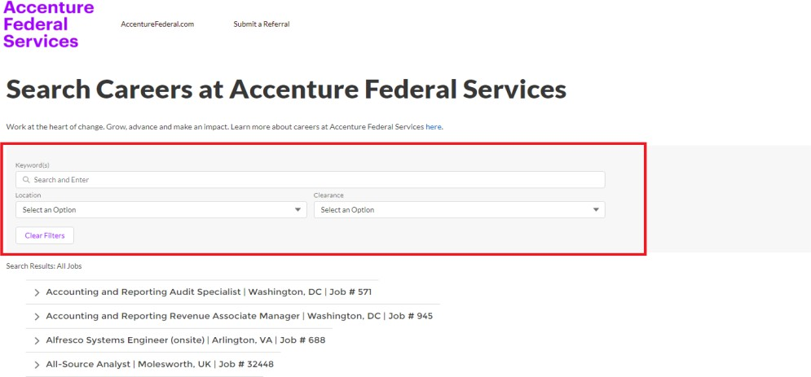

Image 1

In comparison, Alvarez and Marsal’s job page allows applicants to filter jobs by category, location, keywords, job type, and remote type, and displays jobs in a more visually distinct way, leading to a better user experience.

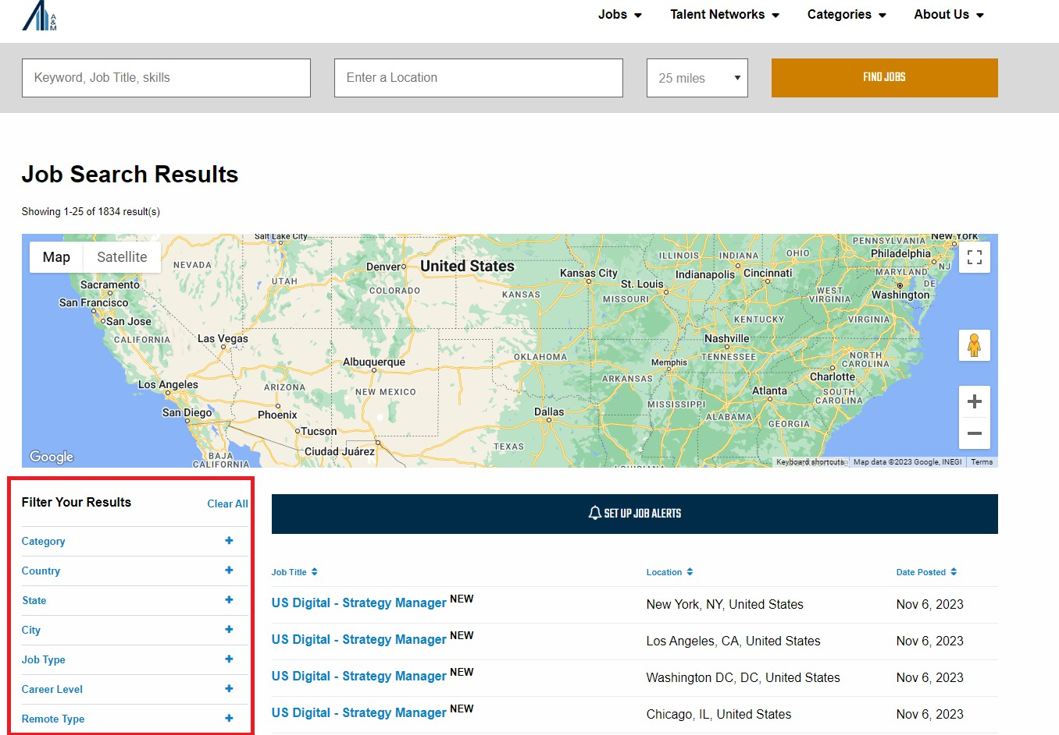

Image 2

General navigation on the Federal Services page also is made difficult through poor design, one example being the page selection at the bottom being a combo box. This deviates from standard practice on other job web portals; combo boxes are rarely used and are not as easy to use.

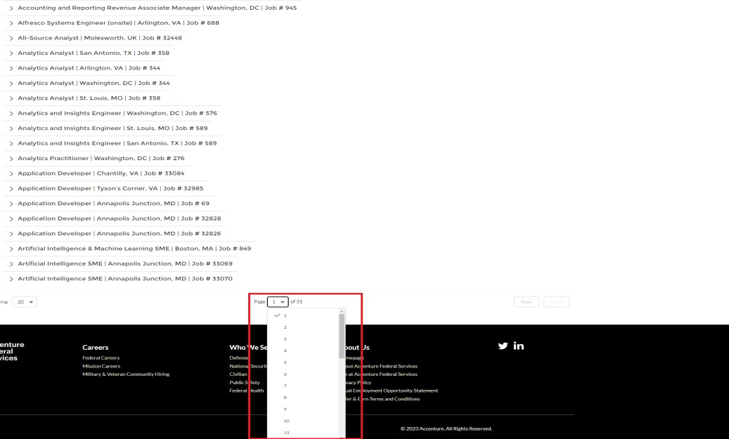

Image 3

Instead of a short list of numbers or a number with an increment and decrement arrow should be used, like on Alvarez and Marsal’s job page.

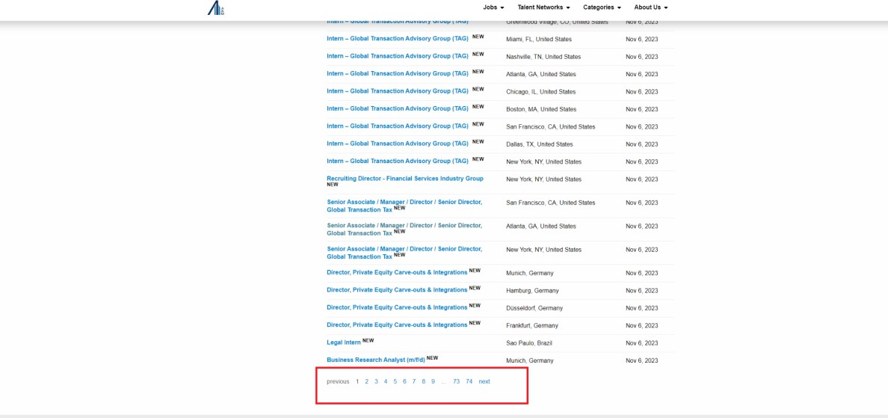

Image 4

In summary, through analysis of the job portals of competing companies, Accenture Federal Services should improve user interface design to enhance overall user experience and search and filtering features available to applicants.

* + 1. ​Use Case Analysis:

Derived from the user requirements, use cases are a clarification of the interaction between a user and a larger system, expanding on the system requirements previously explored in this deliverable. This section covers 3 primary use cases, Generate Applicant Report, Create Job Posting, and Applicant Allocation, central to the functionality of a hiring system, listing their preconditions, normal course, postconditions, exceptions, inputs and outputs and the input and output source and destination.

* + 1. ​Use Case 1

|  |  |  |
| --- | --- | --- |
| **Use Case Name:** Create Job Posting | **ID**: UC-1 | **Priority:** High |
| **Actor:** Hiring Manager / HR | | |
| **Description:** This use case outlines the process a company follows to create and publish a job posting for a specific job vacancy. It covers the steps involved in defining the job details, requirements, and responsibilities and then sharing this information with potential candidates through various channels. | | |
| **Trigger:** Hiring manager is prompted by upper management or a department head to make a new listing | | |
| **Type:** External | | |

|  |  |  |  |
| --- | --- | --- | --- |
| **Preconditions:**   1. Hiring manager is authenticated 2. Job portal is available and on-line | | | |
| **Normal Course:**  1.0 Create Job Posting   1. Hiring manager accesses the job portal 2. Hiring manager creates a blank job posting 3. Hiring manager fills in approved contents in the title, location, description and other fields if applicable 4. Hiring manager verifies the job posting is complete 5. System stores the new job posting, and marks it for public view on the job portal 6. System begins accepting applications for the posting | | | **Information for Steps** Hiring manager credentials [Input]  Job listing contents [Input]  Job listing status [Input] New job listing [Output] Notification of new job having been published [Output] |
| **Exceptions:**   1. Insufficient/Incorrect Details In The Job Listing (occurs at 4):    1. The job posting lacks or has clearly incorrect details in key fields like title, description, location, or salary.    2. The user is warned by the system of the missing or incorrect data    3. The user is able to input, or correct/reaffirm the existing data    4. the job posting is saved as a draft, and the normal course continues | | | |
| **Postconditions:**   1. A new job post is created an publicized to the job portal 2. Applications are now being accepted for the job, will be sent to applicant processing | | | |
| **Summary Inputs** | **Source** | **Summary Outputs** | **Destination** |
| Hiring manager credentials  Job listing information  Job listing status | Hiring Manager Hiring manager  Hiring manager | New job listing  Notification of new job having been published | Job portal datastore Hiring manager |

* + 1. ​Use Case 2

|  |  |  |
| --- | --- | --- |
| **Use Case Name:** Generate Applicant Report | **ID**: UC-2 | **Priority:** High |
| **Actor:** HR | | |
| **Description:** This use case outlines how the HR team successfully generates a holistic and reliable applicant report for candidates to be presented to hiring managers. | | |

|  |  |  |  |
| --- | --- | --- | --- |
| **Trigger: An applicant submits an application** | | | |
| **Type:** External | | | |
| **Preconditions:**   1. The HR team has access to all applicant qualifications and job requirements 2. The system successfully sorts qualifications and requirements to each posted position | | | |
| **Normal Course:**  1.0 | | | **Information for Steps** |
| 1. Applicant applies to position 2. System creates one record for applicant 3. System properly sorts all candidate qualifications into applicant report 4. This report is presented to HR team to sort into proper department | | | Candidate qualifications [Input]  Job requirements [Input] Applicant report [Output] |
| **Exceptions:**   1. System is unable to extract candidate qualifications from the resume (occurs at step 3)    1. Applicant record is marked for human review    2. HR employee manually completes human review, and job requirements and sorts candidate qualifications and requirements status    3. Continue normal course at step 4 | | | |
| **Postconditions:**   1. Hiring managers are presented with full reports for applicants 2. Applicant reports contain all information about a candidate in a centralized database | | | |
| **Summary Inputs** | **Source** | **Summary Outputs** | **Destination** |
| Candidate qualifications | HR system  Hiring Manager / HR | Applicant report | Streamlined the process and update documents portal |
| Job requirements |  |  |  |
|  |  |  | Documents delivered directly to HR and Hiring Managers |

* + 1. ​Use Case 3

|  |  |  |
| --- | --- | --- |
| **Use Case Name:** Allocate Application Submission | **ID**: UC-3 | **Priority:** High |
| **Actor:** HR team | | |

|  |  |
| --- | --- |
| **Description:** This use case describes how the HR team builds and maintains a pool of potential candidates for future job openings. Candidate profiles are constructed from applicant submissions from the Accenture Federal Services job portal, and include an identifier for the candidate, candidate skills, experience, interests, qualifications, and notes about the candidate. HR team members may update and add notes to candidate profiles. | |
| **Trigger:** New candidate profile is requested | |
| **Type:** External | |
| **Preconditions:**   1. HR team have access to all the applicant’s applications and its tracking system 2. The system should have a database of candidates who have applied or been considered in previous recruitment processes | |
| **Normal Course:**  1.0 Applicant Allocation   1. HR team accesses the applicant tracking system 2. The system provides a user interface for creating and maintaining a pool of potential candidates in the form of candidate profiles 3. The HR team categorizes and tags candidates profile based on skills, experience, and interests for easy retrieval 4. The HR team adds candidate profiles to the database, specifying their qualifications and any relevant notes 5. The system stores candidate profile in the database | **Information for Steps**  HR Credentials [Input]  Candidate skills, experience, interests, qualifications, and notes about the candidate  [Input]  Added/Edited Candidate Profile [Output]  System saves candidate profile in database [Output] |
| **Exceptions:**   1. Duplicate candidate profile (occurs at 2)    1. On applicant profile creation and before submission to the database, the system shall perform an automated search to ensure duplicate candidate profiles are not created or published to the database.    2. System alerts user of duplicate record | |
| **Postconditions:**   1. The database of potential candidates is updated as new candidates are added 2. Candidates are categorized and tagged for future reference 3. HR team can easily retrieve and search for candidates based on specific criteria | |

|  |  |  |  |
| --- | --- | --- | --- |
| 4. The system saves the changes and maintains the candidate pool for future job openings | | | |
| **Summary Inputs** | **Source** | **Summary Outputs** | **Destination** |
| HR Credentials  Candidate skills, experience, interests, qualifications, and notes about the candidate | HR team members HR team members HR team members | Candidate Profile Created/Updated  Candidate profile saved in database | Updated candidate database within the applicant tracking system |

# Logical Process Model

Below are the results of my construction of Data Flow Diagrams for the revision of the existing hiring system being utilized by Accenture Federal Services. These data flow diagrams were designed based on the analysis of the as-is system, along with the developed use cases from my second deliverable. Data flow diagrams are a tool used in the systems development life cycle to provide a visual representation of the data flows within a system. These DFDs help teams better understand and analyze systems and processes to successfully develop and maintain information systems.

* + 1. ​Context diagram

This data flow diagram (Figure 1) is the top-level diagram for all other process models existing in the hiring system. The purpose of this diagram is to provide an overview of the system within a single process and the corresponding entities to the given system.

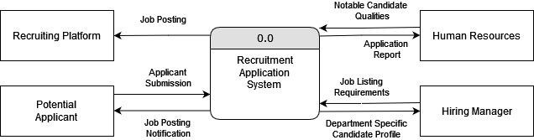

Figure 1

* + 1. Level 0 Diagram

The following diagram (Figure 2) is the exploded view of the recruitment system, where we are introduced to the major sub-processes that exist within the system. This level 0 diagram now introduces internal data flows not seen in the context diagram, to provide a lower-level view of the system. Note that some of these diagram elements are defined in the data dictionary.

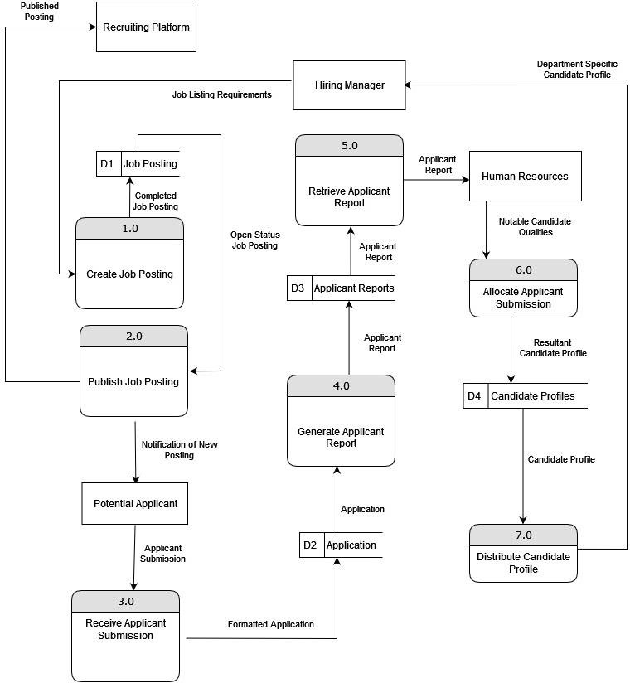

Figure 2

* + 1. Level 1 Child Diagrams

The contents of this section are the applicable level 1 child diagrams of each major sub-process present in the level 0 diagram for the recruiting system. Each diagram's purpose is to further break down the process into multiple lower-level sub-processes. Some of these diagrams will introduce new lower-level elements do not present in the level 0 diagram, such as additional data flows and data stores.

* + 1. Level 1 Process 1 - Create Job Posting

The purpose of this process is to provide a means for the Hiring managers of departments to create a job posting in preparation for posting to external entities. This process contains 4 additional subprocesses and their corresponding data flows. (Figure 3)

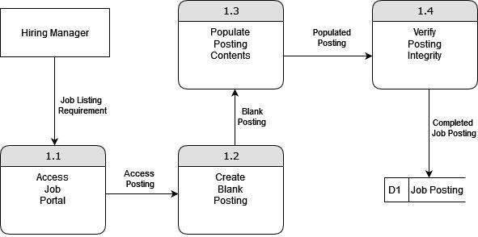

Figure 3

* + 1. Level 1 Process 2 - Publish Job Posting

The purpose of this process (Figure 4) is to provide a means for taking job postings created by the hiring managers and posting them to external entities. This will enable the job posting to be found on the website, as well as notify interested applicants of a new job posting. This process contains 3 additional subprocesses and their corresponding data flows.

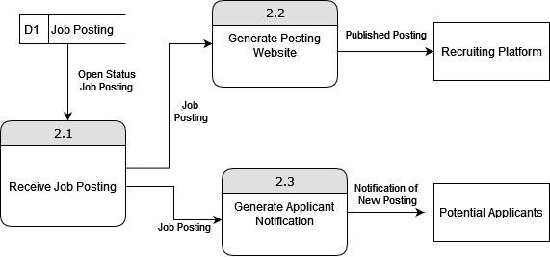

Figure 4

* + 1. Level 1 Process 3 - Receive Applicant Submission

The purpose of this process is to create a method of receiving applications from applicants corresponding to the job posting of interest. This process will verify its completion and confirm the document type in order to store it in the appropriate data store. This process contains 2 additional subprocesses and their corresponding data flows. (Figure 5)

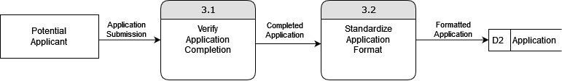

Figure 5

* + 1. Level 1 Process 4 - Generate Applicant Report

This process (Figure 6) creates a way for the application submitted by a user to be processed into a uniform document that can be utilized by the Human Resources Department. This process contains 3 additional subprocesses and their corresponding data flows. An additional data store is also introduced that facilitates the storage of Applicant Records.

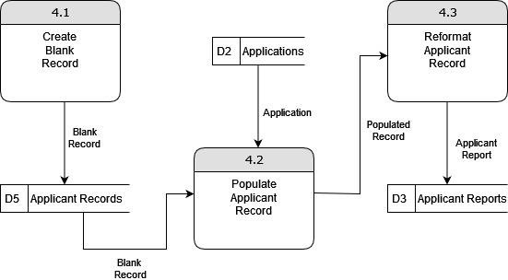

Figure 6

* + 1. Level 1 Process 5 - Retrieve Applicant Report

This process creates a way for the applicant report to be sent to the Human Resources Department. This enables the department to view applicants and use them to later allocate applicant submissions. This process contains 3 additional subprocesses and their corresponding data flows. (Figure 7)

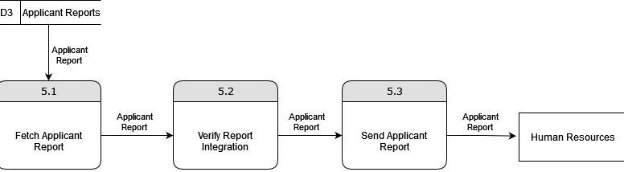

Figure 7

* + 1. Level 1 Process 6 - Allocate Applicant Submission

This diagram (Figure 8) depicts the process that enables the Human Resources Department to create candidate profiles from the existing applicant reports. This is done based on the notable candidate qualities and additional tags and categories are added to the profiles to facilitate easier navigation of profiles. This process contains 4 sub-processes and introduces two new data stores for the tags and categories.

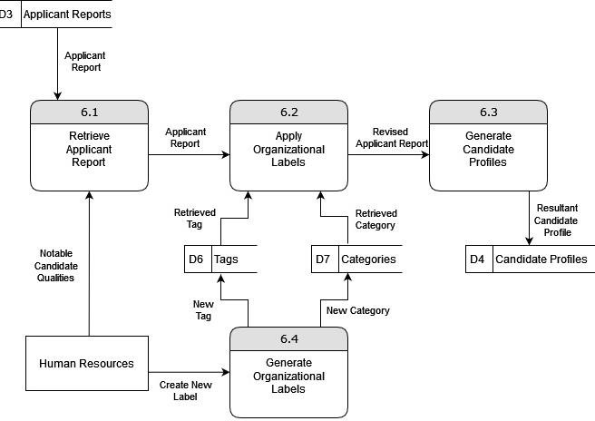

Figure 8

* + 1. Level 1 Process 7 - Distribute Candidate Profile

The last process depicted in Figure 9 is designed to distribute the relevant candidate profiles to hiring managers of departments. This process introduces 3 additional subprocesses and their associated data flows.

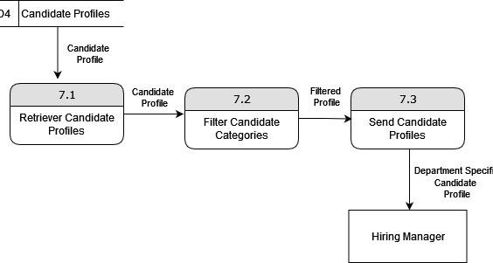

Figure 9

* + 1. ​Data Dictionary

The following Dictionary consists of 10 elements that can be found in the level 0 diagram (Figure 2). This dictionary is not a complete collection, but rather a representative sample of elements found in the diagram. It provides context and descriptions, along with data type constraints that are pertinent to each element.

* + 1. ​Hiring Manager

|  |  |  |  |
| --- | --- | --- | --- |
| **Type** | **Description** | **Contains** | **Data Type Constraints** |
| Entity | This entity represents an individual responsible for the hiring and recruitment process within this company. | This entity will contain attributes that describe the hiring manager as an employee of the company. Example:  Name: John Smith Email: [john.smith@gmail.com](mailto:john.smith@gmail.com)  Phone Number: (222)-333-  3333  Job Title: HR Manager Department: HR Employee ID:123 | Name: VARCHAR  Email: VARCHAR Phone-number: VARCHAR  Department: VARCHAR Employee ID: INT |

* + 1. ​Human Resources Department

|  |  |  |  |
| --- | --- | --- | --- |
| **Type** | **Description** | **Contains** | **Data Type Constraints** |
| Entity | Entity that represents the unit that is responsible for managing employee related information and process. | This entity will contain attributes that describe current employees in the company.  Example:  Employee name: Steve Job Employee ID:33232 Salary: $80,000  Hire Date: 11/10/2002 | Employee name: VARCHAR  Employee ID: INT Department Team: VARCHAR |

* + 1. ​Potential Applicant

|  |  |  |  |
| --- | --- | --- | --- |
| **Type** | **Description** | **Contains** | **Data Type Constraints** |
| Entity | Entity that describes the individuals that are interested in applying for a job through the hiring system | This must contain information about the applicant that should be received by the hiring team.  Example: Name:Robert Eze  [Email:Robert.E@gmail.com](mailto:Robert.E@gmail.com) Resume: a PDF file  Phone Number:(203)-444-4444 Application Date:02/11/2023 | Name: VARCHAR  Email: VARCHAR Resume: BINARY Phone Number: VARCHAR  Application Date: DATE Available Starting Date: DATE |

* + 1. ​New Job Posting

|  |  |  |  |
| --- | --- | --- | --- |
| **Type** | **Description** | **Contains** | **Data Type Constraints** |
| Data Flow | information about a newly created job posting being sent through the hiring system | Job posting details, including job title, description, and posting date | Job Title: VARCHAR Description: MEMO Posting Date: DATE |

* + 1. ​Job Posting

|  |  |  |  |
| --- | --- | --- | --- |
| **Type** | **Description** | **Contains** | **Data Type Constraints** |
| Data Store | Contains all active and archived job postings within the organization | job posting record that includes job titles, descriptions, and posting dates  Example:  Job Title: Lead Software Engineer  Description: Lead software development team for… Posting Date: 2023-10-31 | Job Title: VARCHAR Description: MEMO Qualifications: MEMO Posting Date: DATE |

* + 1. ​Notification of New Posting

|  |  |  |  |
| --- | --- | --- | --- |
| **Type** | **Description** | **Contains** | **Data Type Constraints** |
| Data Flow | This data flow is a notification being sent to potential applicants when the job posting is published | Information about the new job posting, such as the job title and posting date | Job Title: VARCHAR Posting Date: DATE |

* + 1. ​Applicant Submission

|  |  |  |  |
| --- | --- | --- | --- |
| **Type** | **Description** | **Contains** | **Data Type Constraints** |
| Data Flow | The data flow contains data submitted by potential applicants to the job posting | Applicant details, including name, contact information, and submitted application | Name: VARCHAR  Email: VARCHAR Application: MEMO |

* + 1. ​Application

|  |  |  |  |
| --- | --- | --- | --- |
| **Type** | **Description** | **Contains** | **Data Type Constraints** |
| Data Store | The data store is a storage location of all applications submitted by potential applicants. | Application records, including applicant names, contact details, and submitted application content.  Example:  Name: John Doe  Email: [jdoe@example.com](mailto:jdoe@example.com) Application: Cover letter and resume content | Name: VARCHAR  Email: VARCHAR Application: MEMO  Relative Experience: MEMO |

* + 1. ​Applicant Reports

|  |  |  |  |
| --- | --- | --- | --- |
| **Type** | **Description** | **Contains** | **Data Type Constraints** |
| Data Store | The Applicant Reports data store is a point of storage for reports and assessments related to potential applicants | Reports on applicant qualifications, interview feedback, and candidate rankings  Example:  Qualification Report: Candidate John Doe - Strong technical skills  HR Feedback: Candidate John Doe - Excellent communication | Qualification Report: MEMO HR Feedback: MEMO |

* + 1. ​Notable Candidate Qualities

|  |  |  |  |
| --- | --- | --- | --- |
| **Type** | **Description** | **Contains** | **Data Type Constraints** |
| Data Flow | The Notable Candidate Qualities data flow is a data flow for information about specific qualities or skills of notable | Qualities, skills, or attributes of noteworthy candidates. | Notable Qualities: MEMO |

|  |  |  |  |
| --- | --- | --- | --- |
| **Type** | **Description** | **Contains** | **Data Type Constraints** |
|  | candidates |  |  |

# Logical Data Model

Below is my construction of the Entity-Relationship Diagram to show the specific data that is utilized by Accenture Federal Services. The Entity-Relationship diagram was designed based on the data flow diagram and the necessity for a job application. There are also two alternative matrices described below. The first one details information about 3 different design systems and its relevance in regard to technical, economic, and organizational issues. The second matrix details information about different architectures to be considered based on the non-functional requirements described in the previous deliverables.

* + 1. : Entity-Relationship Diagram

Entity-relationship diagrams (ERDs) are used for data modeling and database design. With the use of ERDs, it can help create a structure of a database with the corresponding entities, attributes, and the relationship between them. This particularly shows the data that is generated from each entity that will be used in the system and how they can be related to each other. Below shows an ERD diagram, based on the data flow diagram, that focuses on the static structure of the data in regard to the relationship between applicants, job postings, applications, human resources department, and hiring managers.

Figure 10

* + 1. ​Alternative Matrix 1 - Choosing the Appropriate System Design

In designing a system for job application posting, storage, and retrieval, it is crucial to assess different design approaches based on required functionalities. Given design choices to obtain the to-be system through custom development, purchased packaged system, and outsourcing, the alternative matrix provides a straightforward evaluation of these three options. This matrix guides the selection of the most suitable design by analyzing the technical, economic, and organizational feasibility aspects of the alternative systems and its importance to the project.

Custom Development:

A custom developed system can create a user-friendly web portal where applicants can submit their resumes, cover letters, and other important information. Compared to mixing job applications with other companies, Accenture would be able to create their own web portal solely for the use of potential Accenture candidates. The web portal could implement a secure login system for the HR department and specific hiring managers to access and review submitted applications. With custom development, a database can be created to store applications and their information to make it easy to organize and search for future references and uses; a specific dashboard can be used by the HR department and hiring managers to search, filter, and review applications based on specific criteria. Finally, the system could send automated email notifications to applicants to review their application status and also notify the HR department of new applications.

Purchased Packaged System:

Accenture can purchase a packaged system that consists of an applicant tracking system (ATS) so that it can allow applicants to submit resumes and cover letters through an online portal and the HR department and hiring manager can review, track, and collaborate on applicant profiles. Accenture can also choose a packaged system that can be easily integrated within the existing HR processes with some additional customization; it can ensure that the system allows HR department and hiring managers to access and analyze applicant data within a broader context. With a specific packaged system, it can offer reporting features that show application trends and demographics for data-gathering purposes and the HR department can use analytics tools provided to assess effectiveness of the hiring process.

Outsourcing:

With the use of outsourcing, applicants can submit their relevant job-related information through a third-party platform that specializes in the recruitment process. The HR department and hiring managers can access this platform and review and manage submitted applications. With the use of Cloud-Based services, applicants can upload their resumes, cover letters, and other relevant documents to a secure server and the HR department and hiring managers can access the platform to retrieve and review applications anywhere. Also with outsourcing, software can be implemented to screen applications based on predefined criteria, so the HR department and hiring managers can access pre-screened applicants and reduce time on evaluating all applications.

29

|  |  |  |  |  |  |  |  |  |  |  |
| --- | --- | --- | --- | --- | --- | --- | --- | --- | --- | --- |
| Evaluation Criteria | Relative Importance (Weighted) | Alternative 1: Custom Development (Custom system) | Score (1-5) | Weighted Score | Alternative 2: Purchase Packaged System (ATS) | Score (1-5) | Weighted Score | Alternative 3: Outsourcing (Private Cloud) | Score (1-5) | Weighted Score |
| Technical Issues: |  |  |  |  |  |  |  |  |  |  |
| Scalability | 10 | Can be scalable  - organization can expand the system | 5 | 50 | Less scalable but still has the capabilities depending on system | 4 | 40 | Can be scalable with the use of cloud systems | 5 | 50 |
| Integration | 8 | Perfectly integrated into the as-is systems | 5 | 40 | Not a perfect fit. Some customization and compromises needs to be made | 3 | 24 | Can be perfectly integrated into the as-is systems. | 5 | 40 |
| Security | 12 | Has as much security that is written into the system - dependent on Accenture | 4 | 48 | Security could be implemented by Accenture after purchasing | 4 | 48 | Private clouds has some security but always has the chances of breaches | 3 | 36 |
| Economic Issues: |  |  |  |  |  |  |  |  |  |  |

|  |  |  |  |  |  |  |  |  |  |  |
| --- | --- | --- | --- | --- | --- | --- | --- | --- | --- | --- |
| Initial Costs | 15 | Has high initial costs | 3 | 45 | Low initial costs (depends on the system) | 4 | 60 | Can be costly | 1 | 15 |
| Operating Costs | 10 | Fairly costly to maintain system | 3 | 30 | System is not as costly | 4 | 40 | Fairly costly to maintain cloud | 3 | 30 |
| Organizational Issues: |  |  |  |  |  |  |  |  |  |  |
| User Acceptance | 20 | Users can easily use it but some complications can exist | 4 | 80 | Already tested product so users can easily use | 5 | 100 | Implementing cloud to hold user information might be less accepting | 3 | 60 |
| Training | 15 | Fairly easy to train on system | 4 | 60 | More difficult since it isn’t a perfect fit | 3 | 45 | Fairly easy as cloud can be customized to as-is system | 4 | 60 |
| Change Management | 10 | Hard to change management since system might need to accommodate it | 3 | 30 | Can easily change management since it is a predefined system | 4 | 40 | Cloud management can be given to people with authorized access | 5 | 50 |
| TOTAL | 100 |  |  | 383 |  |  | 397 |  |  | 341 |

Score from 1= poor; 5 = perfect fit

Based upon the alternative matrix above, the purchased package system would be the best option as it allows scalability, integration, and security. It also has the cheapest initial and operating costs out of the three options. The user can easily use the system and training for the system will be more efficient as it is not a complicated system. I believe that this is the best choice as well. Since a system for job applications and potential candidates is not a strategic advantage and it will cost more building from within the organization, it is better to buy a purchased system or outsource. Job applications and storing them for future reference are done by many companies, there are packaged systems that offer all the aspects of the system and can customize the system as well.

* + 1. : Alternative Matrix 2 - Choosing the Appropriate Architecture Based on Non-functional Requirements

This section shows an alternative matrix involving different types of architectures that can be considered to support the system design. It compares the server-based, client-based, thin client- server, and thick client-server architectures with the project’s nonfunctional requirements. This offers a better insight into which type of architecture can support the system design the best that aligns with the project goals.

|  |  |  |  |  |
| --- | --- | --- | --- | --- |
| Non Functional Requirements | Server-based | Client-based | Thin Client- Server | Thick Client- Server |
| Operational Requirements | | | | |
| Mobile Accessibility via Web Portal | ✔ |  | ✔ | ✔ |
| Support for Chromium-based Browsers | ✔ |  | ✔ |  |
| Support for Safari | ✔ |  | ✔ |  |
| Security Requirements | | | | |
| Applicant Information Security | ✔ | ✔ | ✔ | ✔ |
| Access to Applicant Information | ✔ | ✔ | ✔ | ✔ |
| Safeguards against Malicious Submissions | ✔ | ✔ | ✔ | ✔ |
| Edit Job Listing with Authentication | ✔ |  |  |  |
| Cultural/Political Requirements | | | | |
| Non-Facilitation of | ✔ | ✔ | ✔ | ✔ |

|  |  |  |  |  |
| --- | --- | --- | --- | --- |
| Discriminatory Practices |  |  |  |  |
| Demographic Information Hiding | ✔ | ✔ | ✔ | ✔ |
| Promotion of Diversity and Inclusion | ✔ | ✔ | ✔ | ✔ |

Server-Based Architecture:

A server-based architecture can provide mobile accessibility and supports various browsers. Since the server is responsible for processing, it allows a consistent user experience among various devices and ensures a more centralized control and management. Thus, it meets all the operational nonfunctional requirements. Due to the centralized control, it consists of robust security measures and ensures the confidentiality of applicant and employee information which fulfills the security nonfunctional requirements. Finally, the server-based architecture supports non-discriminatory practices and promotes inclusion and diversity.

Client-Based Architecture:

The client-based architecture is not the best fit for mobile accessibility and support of various browsers; they depend highly on the design of client applications. The security requirements can be met; however, it is more challenging as the distribution of data and control varies. Finally, the cultural and political requirements can be met if the client-based architectures are designed to accommodate these requirements. Overall, the client-based architecture does not fulfill the majority of the nonfunctional requirements and should not be considered.

Thin Client-Server Architecture:

The thin client-server architecture provides mobile accessibility and is a mix of mobile and centralized support. The security requirements can be fulfilled but it is not as controlled as the server-based model. The cultural and political requirements can be fully supported by the thin client-server architecture.

Thick Client-Server Architecture:

A thick client-server architecture can be challenging to implement mobile accessibility and browser support for Chrome and Safari. It is similar to the thin client-server architecture in terms of security requirements, but client-side processing must be considered. Finally, this architecture can fully support the cultural and political requirements.

Overall Architecture Decision:

Considering the operational, security, and cultural/political nonfunctional requirements along with the evaluation of server-based, client-based, thin client-server, and thick client-server architectures, it is best to adopt the server-based architecture for the Accenture Federal Services job board web portal. This is the best option as it supports all of the nonfunctional requirements. Even though the server-based architecture provides a consistent mobile experience, it does not offer a strong user interface; this is due to the priority of accessibility over a visually appealing interface. The client-based architecture is more responsive than a server-based architecture but

due to the centralized control and security of the server-based architecture, it is the better choice. The trade-offs are carefully considered and aligns with the project’s goals.

* + 1. : Hardware and Software Specifications

Since the overall architecture decision highly supports server-based architecture, it can be broken down into standard client, web server, application server, and database server. The provided hardware and software shows the minimum requirements and standards that each component should meet in order to efficiently process applications from applicants, HR department, and hiring managers.

|  |  |  |  |  |
| --- | --- | --- | --- | --- |
|  | Standard Client | Standard Web Server | Standard Application Server | Standard Database Server |
| Operating System | Windows 10 | Linux | Linux | Linux |
| Browser Support | Chrome, Firefox, Edge | N/A | N/A | N/A |
| Database Management System | N/A | N/A | PostgreSQL | mySQL |
| Processor | Core i5 2.8GHz or higher | Dual Xeon  2.5GHz or higher | Dual Xeon  2.5GHz or higher | Quad-core Xeon  2.8 GHz or higher |
| RAM | 8GB or higher | 16GB or higher | 32GB or higher | 64GB or higher |
| Storage | 256GB SSD or  higher | 500GB SSD or  higher | 1TB SSD or  higher | 2TB SSD or  higher |
| Network | Wifi and Ethernet | Gigabit Ethernet | Gigabit Ethernet | Gigabit Ethernet |

# User Interface, Physical Process & Data Models

* + 1. ​Structure Chart

A structure chart is a graphical representation that illustrates the modular structure and organization of a software system. It uses symbols to represent modules, their relationships, and the flow of data and control within the system. When applied to a recruitment application system, a structure chart can provide a clear and visual depiction of the system's architecture, helping developers and stakeholders understand how different components interact. The process that was chosen to be expanded on was “Retrieve Applicant Report.”

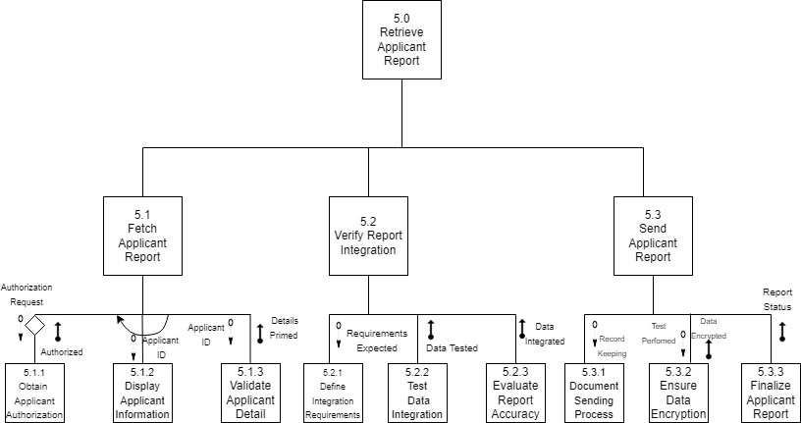

Figure 11

* + 1. ​User Interface

To enhance the consistency of the user interface across the entire hiring system website for Accenture Federal Services, several key interface standards and design principles should be carefully considered. Consistency in design is pivotal to simplify user interactions and reduce the learning curve associated with navigating different parts of the system.

Firstly, visual consistency plays a crucial role in providing users with a unified and predictable experience. Adhering to Accenture's brand guidelines for color schemes, typography, and styling ensures a cohesive visual identity. Consistency in the placement of navigation controls, buttons, and other UI elements across various pages promotes familiarity and ease of use. A standardized menu structure and navigation controls ensure that users can seamlessly traverse the system.

Implementing visual indicators helps users understand their current location within the hiring system, providing a clear sense of orientation.

Terminology consistency is a fundamental principle to avoid confusion. Using the same terms and icons for similar actions, such as search functionalities, throughout the system facilitates a shared understanding of how operations are performed. For example, if the term "Applicant" is used in one section, we would avoid using "Candidate" in another section to refer to the same entity. Consistency in language extends to form fields, buttons, and reports, ensuring that users encounter familiar terminology in every interaction. This practice is crucial because it establishes a sense of familiarity and predictability for users, mitigating confusion and enhancing overall usability. This uniformity in language becomes especially important for users who may be engaging with various aspects of the system, such as filling out forms, clicking on buttons, or reviewing reports. Consistency ensures that users do not encounter unexpected language shifts, reducing the risk of errors, misunderstandings, and frustration during their interactions.

While maintaining overall consistency, it's essential to strike a balance in report and form design.

Introducing distinctive elements, such as color variations or different title sizes, can help users distinguish between similar components. This addresses the challenge identified in studies where excessive consistency in reports and forms led to difficulty in perceiving differences.

Furthermore, alignment with industry standards and commonly used commercial software, such as web-like interfaces resembling those familiar to users, can significantly reduce the learning curve. Users who are accustomed to web interactions can leverage their existing knowledge, enhancing their efficiency in navigating the hiring system.

In conclusion, a thoughtful implementation of these interface standards and design principles will contribute to a harmonized and user-friendly hiring system for Accenture Federal Services. By prioritizing visual, navigation, and terminology consistency, and carefully considering distinctive elements, the user interface can become a powerful tool for enhancing usability and predictability across the entire system.

* + 1. Interface Design Prototype

Interface design prototypes, particularly wireframes, play a crucial role in shaping the visual and interactive aspects of a hiring website. They provide a tangible representation of the layout and functionality, focusing on the user experience without delving into the database structure. They illustrate how job postings, applicant profiles, and other relevant information are presented on each page, ensuring a logical flow of content. Below, I opted to create individual wireframes for key pages such as the home page, job list, job detail, job posting, and applicant profile as a strategic approach in the design process. This decision was driven by the need to establish a visual blueprint that not only streamlines collaboration between design and development teams but also ensures a cohesive and user-centric design.

The high-fidelity wireframe for the homepage (Image 5) of the job hiring system emphasizes visual consistency, ensuring a seamless and intuitive user experience. The design incorporates a clean and cohesive interface, with consistent color palettes, typography, and layout throughout. For the functionalities related to job searching and resume uploading, the wireframe prioritizes user-friendly features. The search bar is prominently positioned, offering users an easily accessible means to explore job opportunities. Additionally, the wireframe includes a straightforward and user-centric resume upload feature. Users can easily navigate to the resume upload section, where they are guided through a simple and intuitive process.

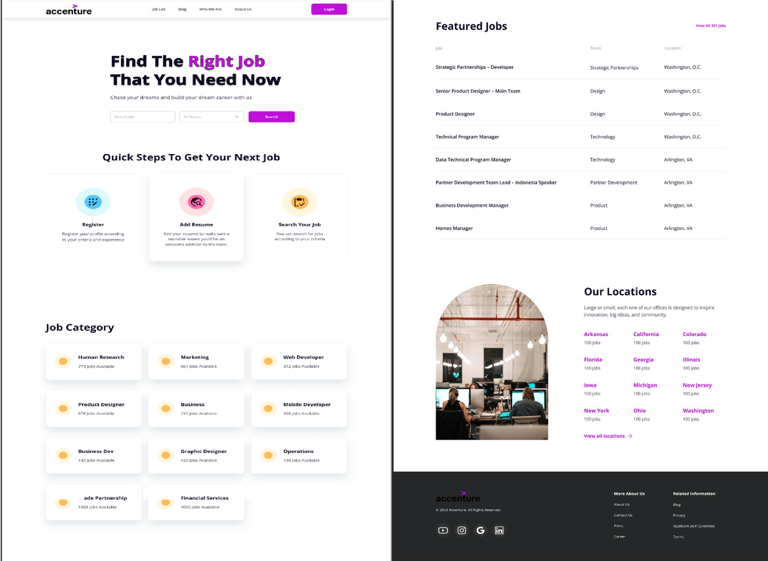

Image 5 Image 6

In the lower part of the homepage wireframe for Accenture Federal Services' job hiring system (Image 6), visual consistency remains a key focus. The design maintains the established color schemes, typography, and layout for a cohesive look and feel. Featured jobs are prominently displayed, employing an organized and visually appealing table format that showcases key details such as job titles, locations, and team designation. The footer of the page is strategically utilized to offer additional functionality and information. Social media buttons are incorporated, allowing users to connect with Accenture Federal Services on various platforms. Additionally, the footer includes links to related information, such as contact information, terms and conditions, and the link to the career page.

On the job list page wireframe for Accenture Federal Services (Image 7), the left side of the page is dedicated to a robust filtering system that enhances user navigation and customization. The filtering system includes intuitive options for departments, employment types, and state/region, allowing users to customize their search easily. The design maintains visual consistency with the homepage, ensuring a seamless transition for users.

The job details page (Image 8) for Accenture Federal Services maintains a clear and organized presentation of information. Key details are neatly placed, and sections are distinctly separated for easy differentiation. At the top of the job posting page for Accenture Federal Services, the name of the position and its location is prominently displayed in larger text. This design choice ensures that users are consistently aware of the specific position they are considering, reinforcing clarity throughout their interaction with the job posting. This approach enhances user engagement and understanding by prominently featuring essential information. A visually apparent "Apply Now" button simplifies the application process, ensuring easy access for users. The design upholds visual consistency with established color schemes and typography.

The job posting form (Image 9) includes tabs for different sections, such as Company Details, Job Details, and Candidate Requirements, streamlining the process of inputting and managing relevant information. Additionally, the most critical details, such as the position and pay information, are strategically highlighted and easily accessible to ensure efficient and accurate data entry. This user-friendly design aims to simplify the task of posting job information for HR professionals, allowing for a seamless and effective process. Visual consistency is maintained, aligning with the overall design of the rest of the job portal pages to provide a cohesive and professional appearance.

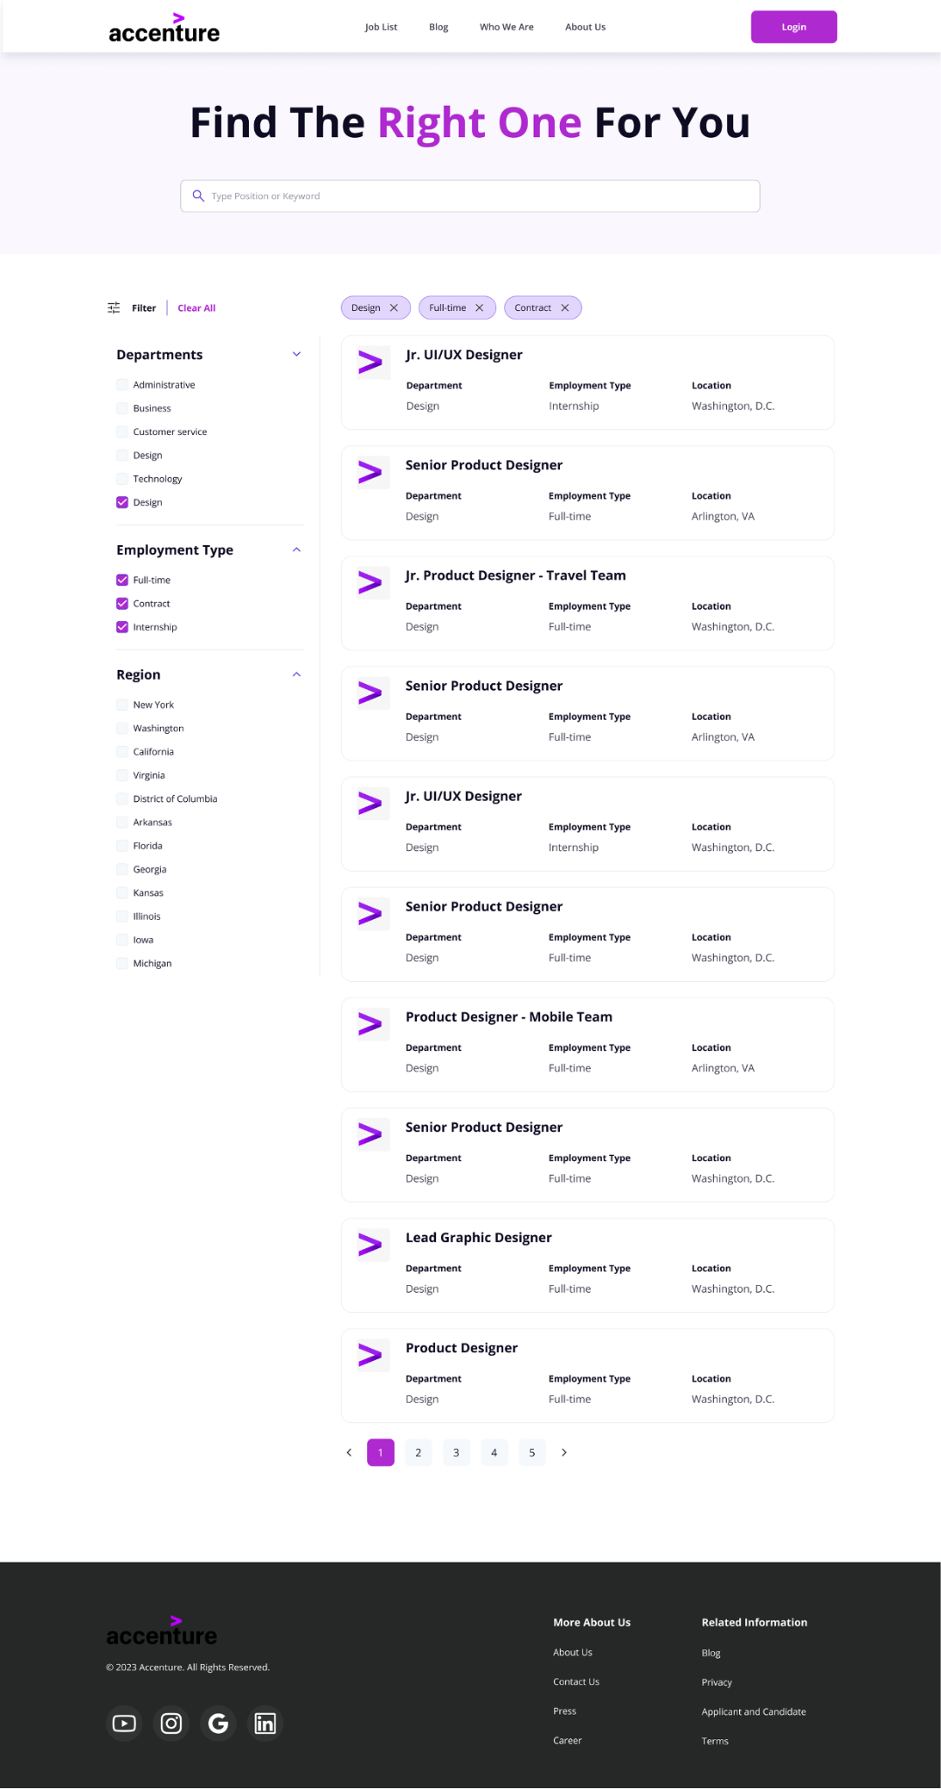

Image 7

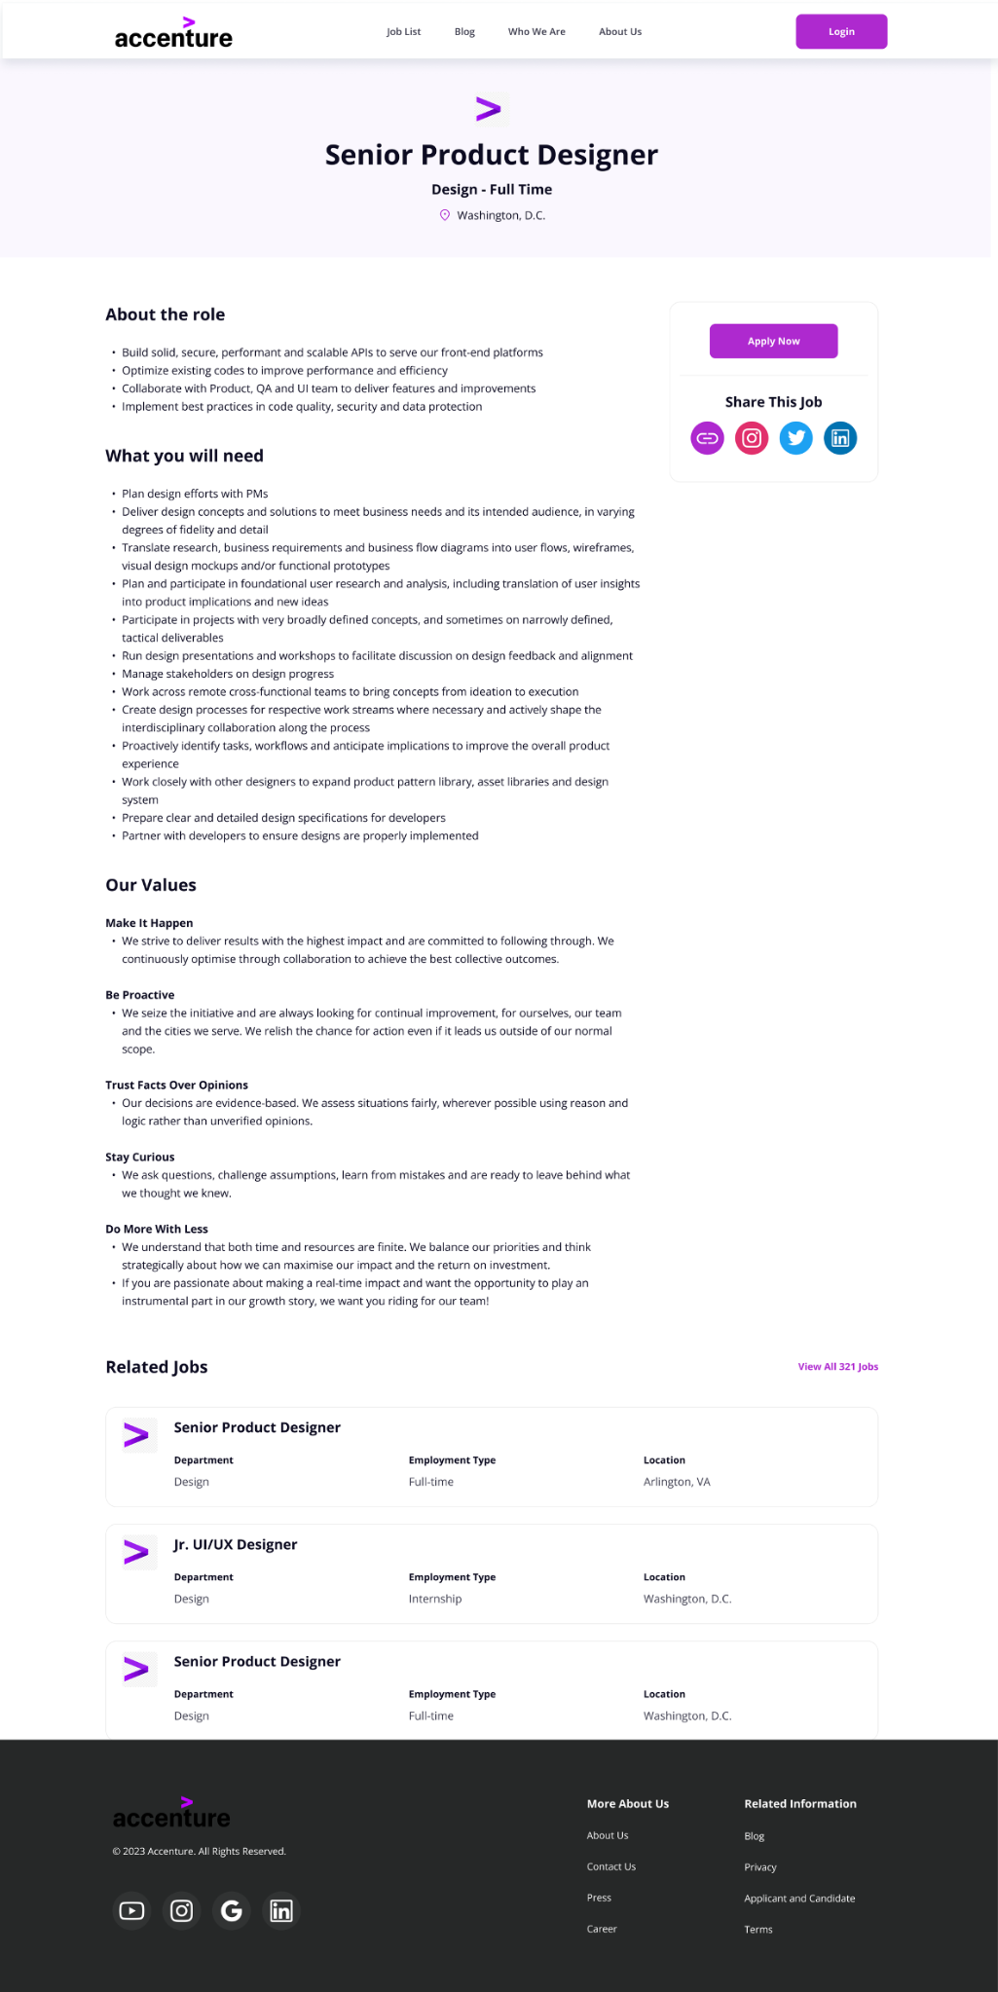

Image 8

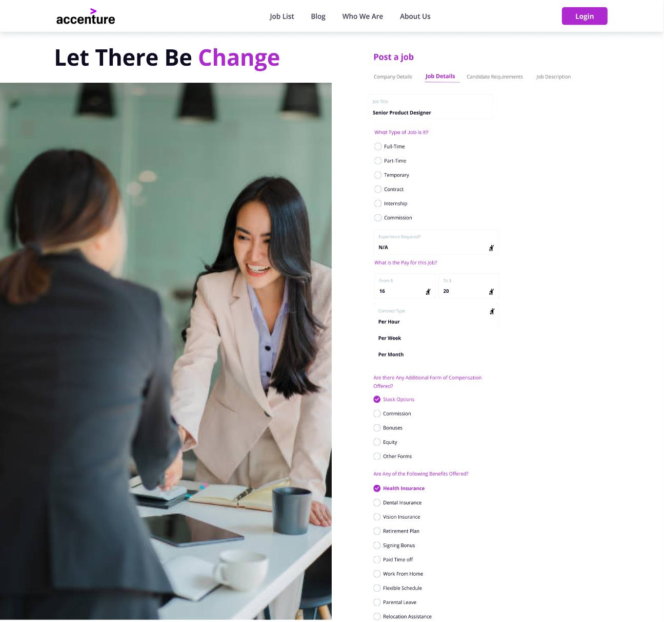

Image 9

The Candidate Summary (Image 0) page for Accenture Federal Services, tailored for HR professionals, offers easy access to essential candidate information. Key features include a concise candidate summary section, a dedicated work experience overview, and a prominently placed link for quick access to the candidate's resume. This streamlined approach facilitates efficient candidate assessment and enhances the HR user's experience on the platform. This page also includes a visually apparent "Schedule Interview" button placed at the bottom of the page. This button allows HR users to efficiently initiate the interview scheduling process with ease, streamlining the workflow and enhancing the overall user experience.

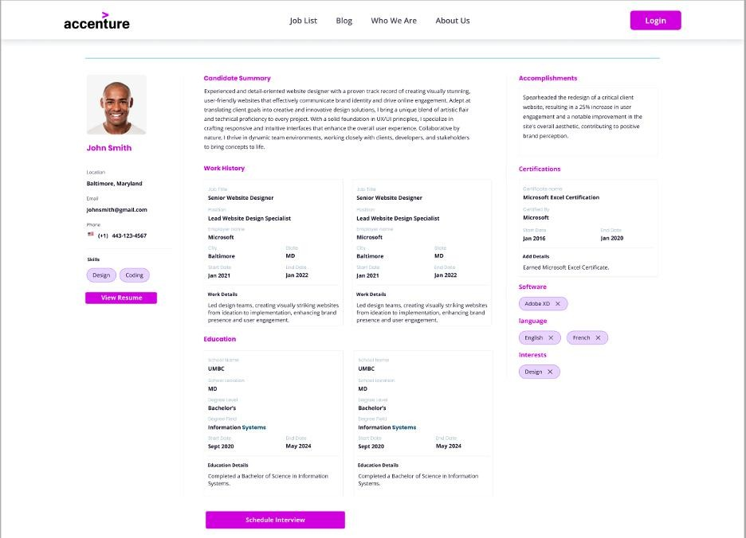

Image 10

The Candidate Report page (Image 11) for Accenture Federal Services, designed for Hiring Managers or HR departments, features a tabular layout with filtering columns as tabs. The report includes essential candidate details such as name, stage in the hiring process, and acceptance or rejection status. A visual star rating system is incorporated for quick evaluation. Above the table includes additional filtering tabs, allowing users to filter candidates by date of applications and by associated tags. The design maintains visual consistency with established color schemes and typography, providing a streamlined and efficient candidate management experience.

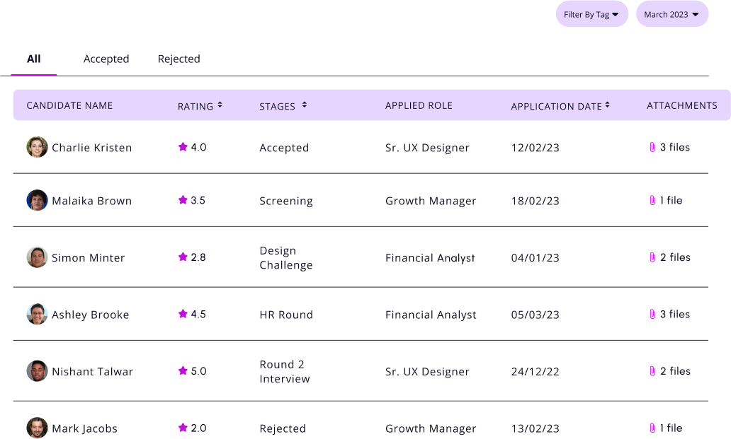

Image 11

* + 1. ​Physical Process Modeling

Below is the Physical Data Flow Diagram, which mirrors the logical DFD's foundational components while incorporating additional details crucial to system construction. The Physical DFD serves as a blueprint that communicates the "systems view" of the new hiring system. It encapsulates the nuanced characteristics of the impending system, offering an improved understanding of its construction and operation. In crafting the physical process model for the hiring process at Accenture Federal Services, physical process models become indispensable tools during the design phase, revealing implementation intricacies and clarifying how the eventual system will operate.

Figure 12

* + 1. ​Physical Data Modeling

A Physical Entity-Relationship (ER) Diagram is a graphical representation that illustrates the structure of a database at a detailed level, capturing the physical implementation of the data model. Unlike its logical counterpart, which focuses on the relationships and entities in an abstract manner, the physical ER diagram delves into the specifics of how data is stored and accessed within a database. It includes details such as data types, primary and foreign keys, indexes, and constraints, providing a comprehensive blueprint for database designers and administrators. This diagram serves as a crucial guide for the actual implementation of a database, aiding in the creation of tables, defining relationships, and ensuring the optimization of data retrieval and storage. The physical ER diagram bridges the gap between the abstract design phase and the tangible database system, offering a visual representation of the details that make up the backbone of a well-structured and efficiently functioning database.

Below is the construction of the Physical Entity-Relationship Diagram that shows the specific data types and their corresponding character limit. Each of the keys for the entities are integer data types. Names, email addresses, and phone numbers are common attributes represented as varchar data types which is a string of letters. The details that go into the applications are also varchar data types. The dates in which the applicant process flows are accompanied by the data type called date. Lastly, to be more inclusive, the char data type was used for gender.

Figure 13

46

# Appendix: Administrator Notes

* 1. ​Systems Request Notes
     + Overall, very good with conveying the business problem, but I need to identify challenges and difficulties with similar vigor.
     + I have formatting issues, mainly in whitespace, and the lines being double spaced.
     + I was missing the business requirements description, although I do briefly cover that.
     + I should probably focus also on the backend, what HR managers are looking at, just the job portal frontend may be too narrow (filtering is likely a good thing to do here)
  2. ​Requirements Definitions & Use Cases Notes
     + Rename 2nd use case.
       - “Maintain Applicant Pool” was thrown around as a possibility.
     + Expand the exceptions for each use case.
     + Elaborate and expand summary and source inputs for use case 2.
  3. Logical Process Modeling Notes
     + Advises against use of UMBC logo but if used make sure to include disclaimer statement in italics at the end, should be reserved for professional collaborations with faculty.
     + Recruitment application system- “Talent Acquisition management system” is a good buzz word we could utilize.
     + Hiring manager should have something sent back to it, law of balancing.
     + Level 0 has an additional entity for job posting that wasn’t included.
     + Entities should be boxed or rectangular.
     + Arrows should be on the outside instead of between the lines.
     + Website entity should be “federal web services portal.”
     + Numbering scheme should be like “1.0.”
     + Diagram can be oriented left to right, expand the size of middle entity to get away with nice parallel structure on either side.
     + Balancing violations
     + Did more processes than what was needed but “that’s okay”, keep it to 3-7
  4. Logical Data Modeling Notes
     + Font size for the ERD should be increased to be more readable.
     + Job_ID is added as a Foreign Key to Candidate Profile Entity
     + TAG and CATEGORY assumptions are changed to prevent M:N relationship and establish 1:N relationships.
       - One report has multiple tags and categories.
     + Two more attributes are added to Application Entity and Candidate Profile Entity
     + Change relationship name to “Assigns and Is Assigned By.”
  5. ​User Interface, Physical Process Modeling, and Physical Data Modeling Notes
     + Put images in part 7 side by side so that the user can view the entire page without scrolling.
     + Change the applicant report and candidate profile to make it look more like the view from administrator than external user viewpoint.
       - Change it to make it look like a table so that it many applicants can be seen by hiring manager and HR department.
       - Change the name of the candidate profile.
     + Include exclusive comments on the images.